12.86: a) To get from the circular orbit of the earth to the transfer orbit, the spacecraft’s energy must increase, and the rockets are fired in the direction opposite that of the motion, that is, in the direction that increases the speed. Once at the orbit of Mars, the energy needs to be increased again, and so the rockets need to be fired in the direction opposite that of the motion. From Fig. (12.37), the semimajor axis of the transfer orbit is the arithmetic average of the orbit radii of the earth and Mars, and so from Eq. (12.19), the energy of spacecraft while in the transfer orbit is intermediate between the energies of the circular orbits. Returning from Mars to the earth, the procedure is reversed, and the rockets are fired against the direction of motion. b) The time will be half the period as given in Eq. (12.19), with the semimajor axis a being the average of the orbit radii, 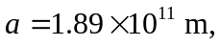 so
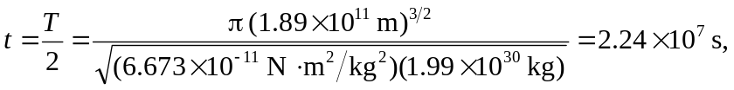

which is more than 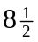 months. c) During this time, Mars will pass through an angle of 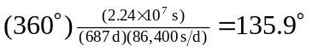, and the spacecraft passes through an angle of 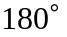, so the angle between the earth-sun line and the Mars-sun line must be 

